Name Per.

Practice Test: *Include Units w/ Each Answer!!!*

Answers

1. C=

A=

2. C=

A=

3. P=

A=

4. P=

A=

5. P=

A=

6. P=

A=

7. P=

A=

8. P=

A=

Chapter

8

**Round each answer to the nearest 10th.**

**Find the circumference and area of the circle. Use 3.14 or** 

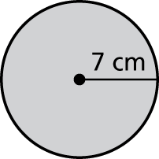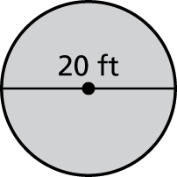1. **2.**

9cm

24ft

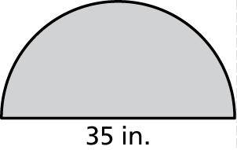Find the perimeter and area of the semicircle.

3. 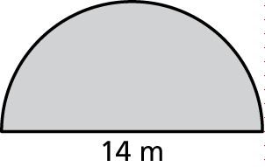 4.

15cm

40 in.

Find the perimeter and area of the figure.

6 cm

11cm

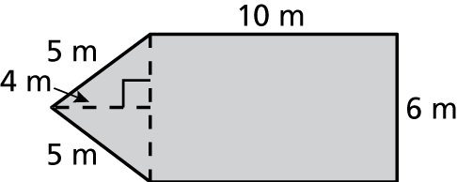 5. 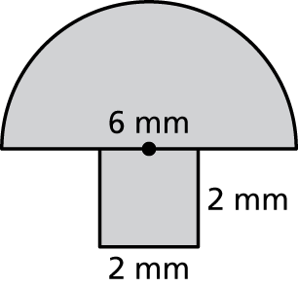 6.

3 cm

6 cm

4 mm

4 mm

7 in

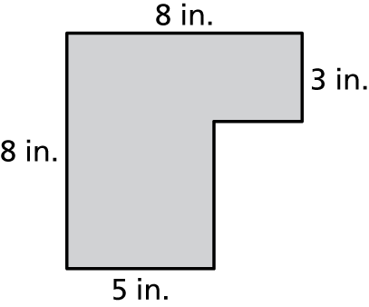 7. 8.

9 m

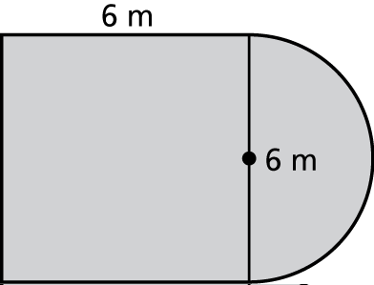

2 in.